|  |  |  |  |  |  |  |  |
| --- | --- | --- | --- | --- | --- | --- | --- |
| DSDM Atern Project Approach Questionnaire | | Indicate the Closest Collective opinion | | | | | Where appropriate, command on issues or risks related to a more negative response to this aspect of the DSDM-Atern approach |
| Ref | Statement | Strongly  Agree | Agree | Neutral | Disagree | Strongly  Disagree |  |
| 1 | The business driver behind the project is clearly stated and is visible to all members of the project team. |  |  |  |  |  |  |
| 2 | The Business Sponsor and/or business visionary demonstrate clear ownership of the project. |  |  |  |  |  |  |
| 3 | The Business Sponsor, Business visionary and Technical Coordinator all understand and accept the DSDM Atern Philosophy. |  |  |  |  |  |  |
| 4 | The development has a clearly-defined timescale. |  |  |  |  |  |  |
| 5 | The requirements can be priorities and there is flexibility to accept that not all requirements are “Must Have” requirements. |  |  |  |  |  |  |
| 6 | Requirements have been defined at a high level at the outset of the project, and it is acknowledged that changes are likely during development of the detail. |  |  |  |  |  |  |
| 7 | It is accepted that the detail of both the requirements and the solution will emerge as the project progress. |  |  |  |  |  |  |
| 8 | The business sponsor and Business Visionary are aware of the importance of active business involvement and have the willingness and authority to commit appropriate business resources to the project as required. |  |  |  |  |  |  |
| 9 | The business ambassadors are sufficiently empowered to guide the day to day evolution of the solution. |  |  |  |  |  |  |
| 10 | The solution developers are sufficiently empowered to provide the best solution they can from a business perspective within pre-agreed architectural constraints. |  |  |  |  |  |  |
| 11 | Solution development resources are allocated at an appropriate level and the team will be largely stable through the project(or at least, throughout each increment). |  |  |  |  |  |  |
| 12 | The Project Team and Solution Development team are able to adopt the roles and responsibilities within DSDM Atern. |  |  |  |  |  |  |
| 13 | It will be possible for the Solution Development team are able to adopt the roles and responsibilities within DSDM Atern. |  |  |  |  |  |  |
| 14 | The Solution Development team (including both business and solution development resources) will have the appropriate collective knowledge and/or technical skills to deliver the solution. |  |  |  |  |  |  |
| 15 | The Solution Development team (including both business and solution development resources) will have the appropriate soft skills(communication, negotiation etc.) to work effectively with each other and those around them. |  |  |  |  |  |  |
| 16 | Strategies for continuous communication and collaborative working practices are sufficient to clearly support iterative development of the solution. |  |  |  |  |  |  |
| 17 | The development technology tools and techniques support an iterative approach to solution development. |  |  |  |  |  |  |
| 18 | There are no technical, contractual or other constraints to prevent the solution being broken into increments for development and delivery(even if the products of such increments are not deployed immediately). |  |  |  |  |  |  |
| 19 | All project participants understand and accept that on-time delivery of an acceptable solution is the primary measure of success for the project. |  |  |  |  |  |  |
| 20 | All parties accept that continual assessment of the fitness for purposes of all deliverables during development is essential. |  |  |  |  |  |  |
| 21 | There are no mandatory standards or practices in force that will work against the evolution of a solution from a baselined set of high level requirements. |  |  |  |  |  |  |

Plan

Evolve

Review

Identify

BB needs to store all inventory lots from each warehouses. Therefore, the Business Ambassador, web Designer, solution developer and Business Analyst will be required. This will take approximately 1 hours.

The developed solution will be demonstrated to the Business ambassador and the Business visionary. The solution registers the product but is not showing them on the web page. About 2 hours will it take for review.

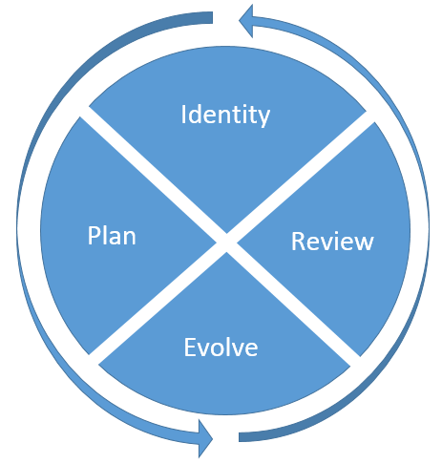

All the required information fields will be listed from the business ambassador’s information. A UI will be designed by the web designer. Creation of the sample database and coding will be done by the solution developer. Finally, the solution tester will do the final test of the complete solution. This session should go not more than 2 hours.

Business analyst will analyze the business needs with the help of business ambassador. The designer will design UI based of the analyzed requirements. The developer will develop and connect a sample database based on the requirements and will do the coding for the development. Finally, the tester will do the testing of the final solution. This session should go for 11 hours.

The developed solution will be demonstrated again in front of Business ambassador and the Business visionary. If it needs further development will loop again. If they are satisfied the development will be stopped. About 3–– hours will it take for review.

Previous sprint doesn’t full-fill the requirements. Therefore, further development is required. This session will take approximately 1 hours.



At this stage how the required stages will be modified or added are described with the involvement of the Solution Development team. Previously developed solution mistakes or weaknesses will be identified and the development process will be planned. This will take 2 hours.

Business analyst will analyze the requirements again. The designer will modify the design to add further designs. The coder will add additional requirements to the backend database solution and develop the solution. The tester will test the solution with required data again. This process will again take 8 hours.